programs & library holdings  
special events

**ADULT: 3,804**Fiction 2,815  
Non-fiction 989

**JUVENILE: 3,539**Fiction 2,527  
Non-fiction 1,012

**OTHER: 39,869**   
Periodicals 12  
Electronic Books 24,701  
Electronic Audio 8,799 Audio Books 296 Video 782  
Other 5,5279  
**TOTAL HOLDINGS: 47,212**

**PROGRAMS:**The library held 138 programs for  
preschool through adults in 2023.  
We had 1,459 total attendance at these  
programs. Due to grants we were able to do  
more adult programming, at the library and   
at the OFA Senior Center.   
We had 23children, teens and adults register   
for summer reading.

Need a library card? Sign up for one from home! It’s fast & easy – just complete the form on our web page & start browsing over 25,000 titles in our digital collections.

STARCat and Libby, allow Whitesville Public Library Patrons to have access to over a million items. They **also make your library**available 24/7/365.   
Magazines are now available through Libby.

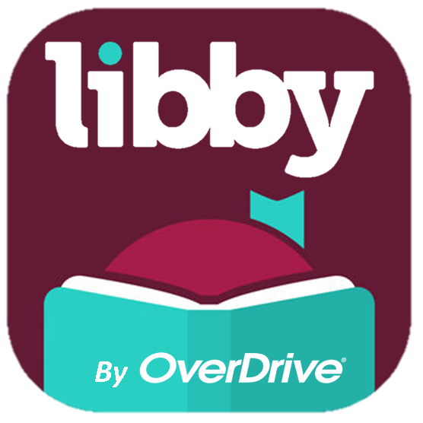 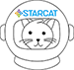



**EVENTS:**Bake Sale   
Ice Cream Social   
Trick or Treat  
Summer Programming  
Craft/Vendor Shows  
Garden Tour  
Memorial Day   
Blue Jay Fundraiser

Peterson’s Test Prep: Test Prep & Career Resources



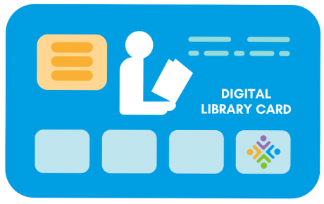

JobNow: Live Career AssistanceLive online job coaching is available every day 2:00 PM to 11:00 PM EST.

