# https://scontent-yyz1-1.xx.fbcdn.net/v/t1.0-9/12003198_927465087325564_2459483376610633680_n.jpg?oh=50b5d1c9be4ed343b34f883c8db1cf2e&oe=584110AB

**Whitesville Public Library**

500 Main St.; PO Box 158, 607-356-3645

[www.whitesvillelibrary.org](http://www.whitesvillelibrary.org)

whitesville@stls.org

**The Library board of Trustees held their reorganizational meeting in July**. Officers elected were: Gay Thistle, President; Marsha Van Vlack, Vice President; Alice Schlichting, Secretary; Caleb Cutler, Finacial Officer. There is one vacant position on the board. If you would like to fill that contact Karen or Gay. Board meetings are the third Tuesday of each month at 6:00 pm. The public is welcome to attend. **(September, 2024 will meet on Tuesday, September 10th)**

**The Board would like to thank everyone for supporting our fundraisers during the summer months.** As usual the gardeners of Whitesville had beautiful displays for all to enjoy. The weather was perfect for a walking tour to visit each one. Thank you Gardeners and Toursists for your support.

**Thank you also for supporting the Ice Cream Social**. As usual many enjoyed the ice cream, desserts and Dick Pensyl’s music. Socializing and food always make for a great evening.

**The library has been very busy this summer**. It has been wonderful having children, teens and families attending programs, coming in for books or just dropping by to do a craft. The Y brought their group each week. What fun we had with them sharing stories, games and crafts and more.It has been fantastic to hear children using the playground most days.

**We were able to host many special programs this summer.** Thank you to the many families that attending our first family movie night. It was a learning experience for us and the night ended much later than we planned but all enjoyed the games, crafts and snacks before the movie. Cris Johnson came and taught us how to make balloon dogs, swords and more. Megan from Tanglewood came and taught us about the owl, ferret, turtle and quail they house. Everyone learned something new about their favorite visitor during that program. Susan Doran from Belvidere Cornerstone used an Arts Grant from the Wyoming Arts Council to teach us the Japanese art of Suminagashi. It was amazing to watch everyone use the same paints, but all designs turned out differently. Susan also received an Arts Grant to make a Community Hair Wreath. She presented an educational program on the history of hair wreaths.

The Pennsylvania Lumber Museum has once again donated a Museum Adventure Pass to the library. This pass admits a family to the Museum. We have purchased two Rochester Museum and Science Center pass and an Empire State Pass with money donated in memory of several Freeman Family members, given by Kim & Steve Thompson. The RMSC passes provides free admission for 2 adults and all children under 18 in their household to the “RMSC Museum & Science Center, the Cummings Nature Center in Naples and the Strasenburgh Plantarium.” The Empire Pass offers “unlimited day-use vehicle entry to NYS parks and the State DEC forests, beaches, trails and more.” These may be borrowed with your library card just like a book or DVD. The borrowing time is 1 week. They are not holdable and must be returned to Whitesville Public Library in person, not the drop box.

**Dates to Remember:  
September** Adult Craft Nights  **TBA**Tuesday 10th - Board Meeting 6:00 pm**\*\***

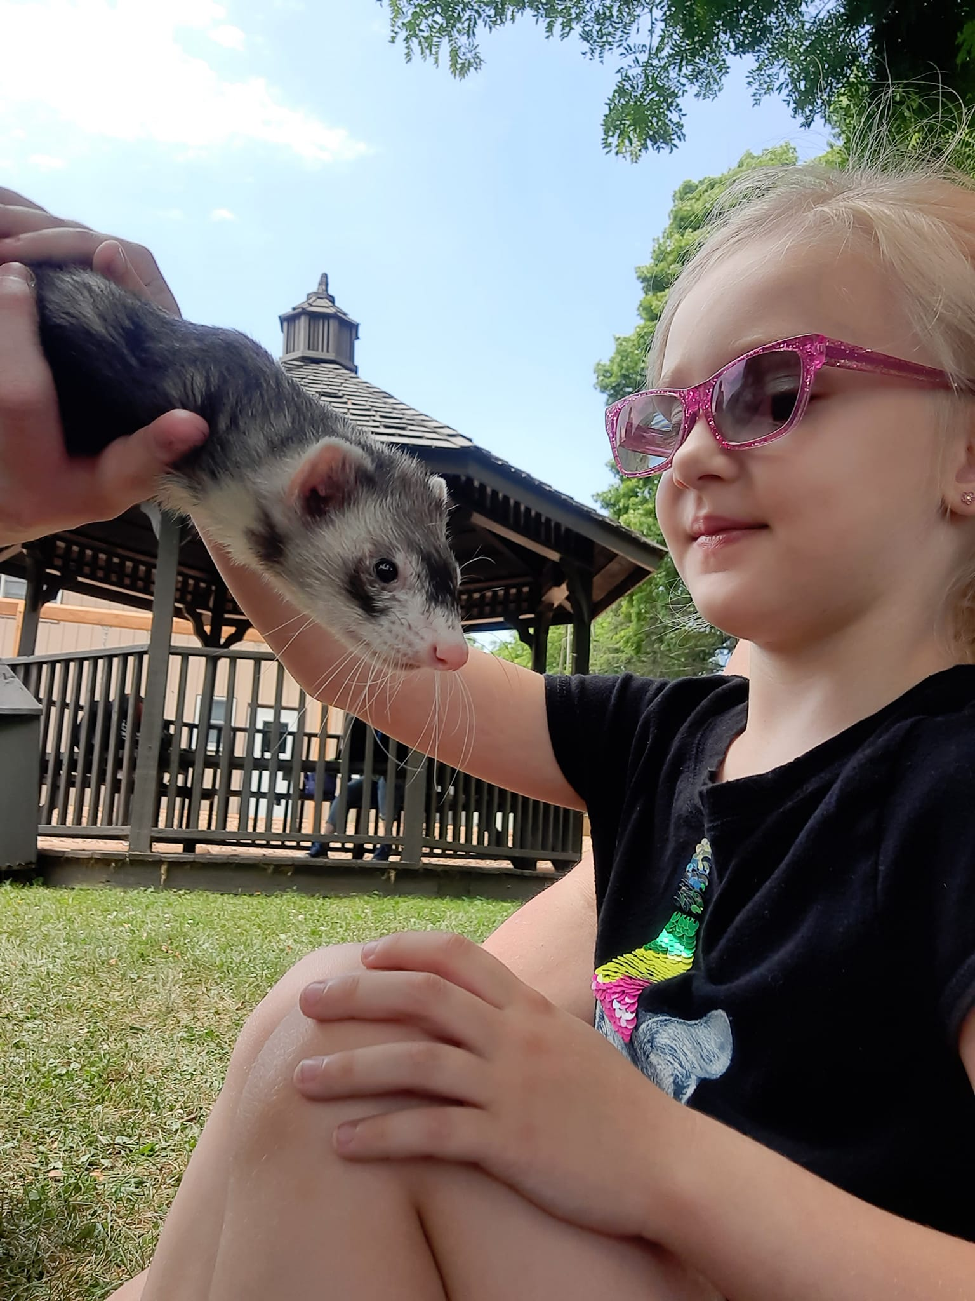



**\*\*** Denotes date change