# https://scontent-yyz1-1.xx.fbcdn.net/v/t1.0-9/12003198_927465087325564_2459483376610633680_n.jpg?oh=50b5d1c9be4ed343b34f883c8db1cf2e&oe=584110AB

**Whitesville Public Library**

500 Main St.; PO Box 158, 607-356-3645

[www.whitesvillelibrary.org](http://www.whitesvillelibrary.org)

whitesville@stls.org

**There is one vacant position on the board.** This position will end in June, 2025, at which time you can choose to run again. If you would like to fill that contact Karen or Gay. Board meetings are the third Tuesday of each month at 6:00 pm. The public is welcome to attend.

**The library was very busy this summer**. We had 63 children, teens and adults register for summer reading. They read a combined 765 hours. We had 376 attend our 19 programs. Thank you to all who participated. Congratulations to the winners of our drawings. We want to say a huge Thank You to Ann at the Corner Market for giving everyone a free ice cream cone for every 3 hours they read this summer. We appreciate your encouraging everyone to read.

**The library is the recipient of a grant from the Manley Foundation.** This grant is awarded through the Key Bank in memory of F. T. and Anna C. Manley. This money will be used to install security cameras in and around the library.

**Angela will be leading crafts for adults during the fall months.** Watch our Facebook page for the month’s project.

**Smokey Bear is turning 80 in 2024.** We will be hosting a birthday celebration in his honor on Monday, October 14th from 10-12. Watch bookbags, Facebook and our webpage for more information.

**On Tuesday, November 12th Annette Gill will be at the library from 2-5 to discuss Medicare benefits and insurance recipients may be eligible to reeive.**  You may call the library to set up an appointment or you are welcome to walk-in.

**The library now has 4 Experience passes you may borrow as you do a library card.** The PA Lumber Museum allows free admission for a family into their museum. The RMSC allows families to enjoy the Science Museum, Nature Garden and limited programs at the Planeterium. The Empire Pass allows free parking in our State Parks. The Empire and RMSC passes were donated by Steve and Kim (Freeman) Thompson in memory of several of Kim’s family. The PA Lumber pass was donated by the museum. These passes are not holdable, can be borrowed for 1 week, checkout and returns must be made at the circulation desk, not the drop box.

**Dates to Remember:  
October November**Monday 14th Smokey Bear 10-12 Tuesday 12th Annette Gill 2:00-5:00  
Tuesday 15th Board Meeting 6:00 pmSaturday 16th Craft with Angela 2:00  
Wednesday 16th Craft with Angela 6:00 Tuesday 19th Board Meeting 6:00  
Thursday 31st Trick or Treat 28th & 29th Closed for Thanksgiving

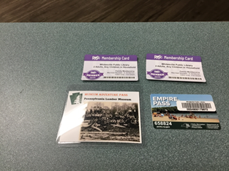  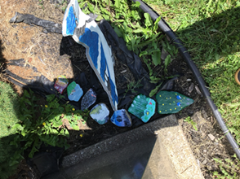

Paint a rock and add It to Bucky Bookworm.

Experience passes